**LinG3D: Visualizing the Spatio-Temporal Dynamics**

**of Clonal Evolution**

**Quick Guide to LinG3D routines**

**Anjun Hu, Awino Maureiq E. Ojwang’, Katarzyna A. Rejniak**

**A quick guide to LinG3D routines**

A suite of MATLAB routines *LinG3D* (Lineage Graphs in 3D) has been created to enable visualization of the spatio-temporal evolution of cellular clones that arise in a computer simulation of tumor growth and/or tumor response to treatments. The *LinG3D* routines display not only the mother cell-daughter cell linear relationship as in a classical lineage tree, but also show which subspace of the whole tumor tissue the particular clone occupies during its development.

Each routine requires information about the history of all cells in order to trace a given cell predecessors or successors. It also requires coordinates of cells present at the times/iterations at which the lineage tree branches are drawn. The cell history data are saved in the following format, one cell per row (file in our code: *cell_history.txt*):

[*cell ID*, *clone ID*, *mother ID*, *birth iter*, *div/death iter*]

where *cell ID* is a unique ID number for the cell, *clone ID* is a number unique to a given clone to which the cell belongs, *mother ID* is a unique ID number of the cell’s mother cell, *birth iter* is an iteration number at which the cell was born, and *div/death iter* is the iteration number at which the cell either divided into two daughter cells or died. If the cell has not divided and is still alive, this element is equal to 0.

Moreover, for each iteration at which the lineage tree branches are drawn (denoted by *_#*), the following files are required to contain the coordinates of all cells present at that iteration, one cell per row (file in our code: *cellXY_#.txt*):

[*cell X*, *cell Y*]

and the corresponding unique cell ID numbers, one cell per row (file in our code: *cellID_#.txt*):

[*cell ID*]

Additionally, if the microenvironmental factor distribution (such as, oxygen or a drug) is to be drawn in the background, the file containing factor concentrations per grid point should be saved as a 2D matrix (file in our code: drug.txt).

Values of several parameters can be specified by the user to represent a particular simulation set up. These include:

1. *xmin*, *xmax*, *ymin*, and *ymax* – spatial domain boundaries to form a rectangular patch of a tissue,
2. *tmin* and *tmax* – temporal boundaries to indicate the initial and final iteration numbers*;* note, that the temporal axis is rescaled for visualization purposes using variable: *timeStep*.
3. *fileStep* – the progression step indicating how frequent the data should be sampled for the 3D lineage three visualization. Note that, more frequent data sampling will show more details of the simulation: smaller changes in cell locations between time points at which the branches are drawn, that results in more tortuous tree branches (Figure S1A). On the other hand, less frequent data sampling for drawing will result in more linear tree branches since some intermediate cell positions will be omitted (Figure S1B).

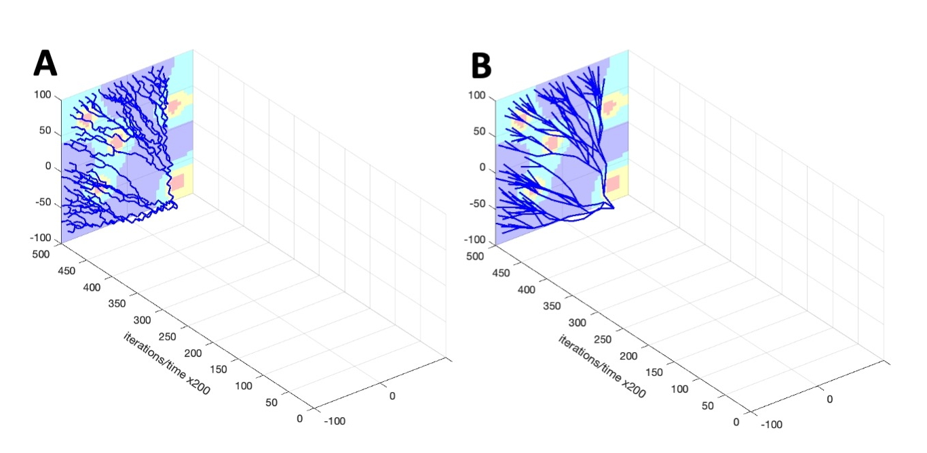

***Fig.S1.* Iteration spacing effect.** A lineage tree drawn every (A) *fileStep*=500 and (B) *fileStep*=5000 iterations;

Moreover, the user can indicate whether to draw the background factor concentration by specifying the value of *isGradient* (1 to draw, 0 not to draw), and whether to save the final figure by specifying the value of *toPrint* (1 to save, 0 not to save).

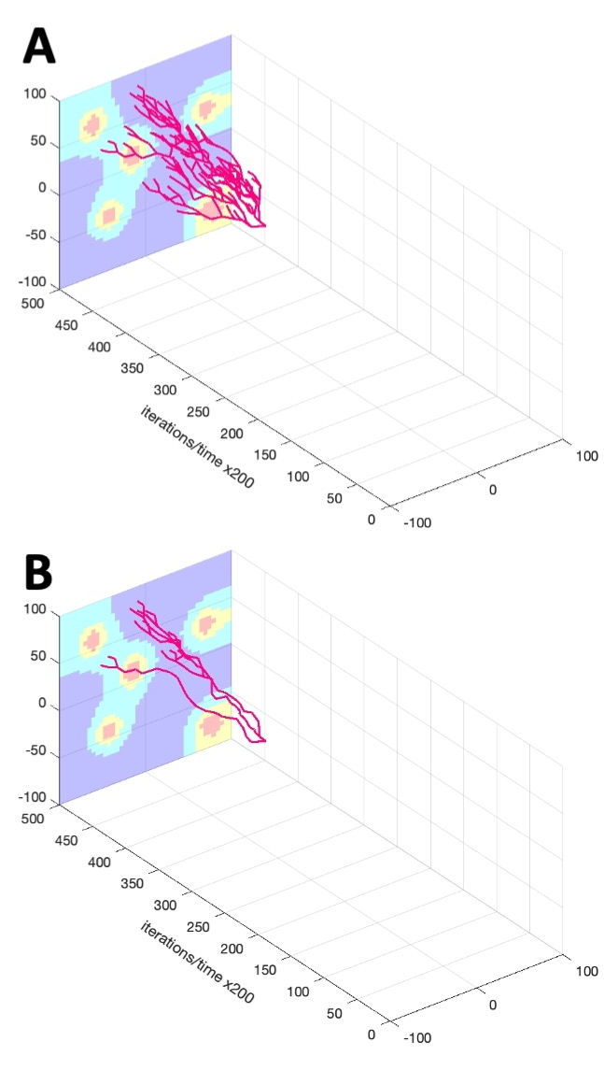

***Fig.S2.* Full vs. Alive lineage tree.** A3D single-clone lineage tree with all cells (A, routine *LinG3Clone*) and cells surviving to the end of simulation (B, routine *LinG3DAliveClone*). For clone #16 and $P^{mut}$ =0.05.

The following visualization options are provided.

*LinG3DAll*: this routine draws a 3D spatio-temporal evolution tree taking into account all cells from all cellular clones. To do so, the routine starts with the initial cell (the tree root), and draws branches of the lineage tree for all mother-daughter cell pairs (straight line segments connecting these two cell positions), until the cells of each clone are included and the terminal cells with no descendants (clone leaves) are reached. The full 3D lineage trees for examples discussed in this paper are shown in the main text in Fig.1A and Fig.1F.

*LinG3DClone*: this routine visualizes a 3D spatio-temporal evolution tree for one selected cellular clone only showing all cells in that clone. This routine starts with the initial cell of the selected clone (the clone tree root) and draws all mother cell-daughter cell branches of the lineage tree for cells belonging to that clone, until all cells are included and the terminal cells with no descendants (clone leaves) are reached (clone leaves). The full 3D lineage tree for clone #16 from an example with $P^{mut}$ =0.05 is shown in Fig.S2A.

*LinG3DAliveAll*: this routine visualizes a 3D spatio-temporal evolution tree for all cellular clones, but includes only those cells that survived to the end of the simulation. The routine starts with cells in the last simulated iteration (tree leaves) and traces back all branches of the lineage tree for all daughter-mother cell pairs until the initial cell of the clone (the clone root) is reached. The 3D lineage trees of alive cells for both discussed examples are shown in the main text in Fig.1B and Fig.1G, respectively.

*LinG3DAliveClone*: this routine draws a 3D spatio-temporal tree for the surviving cells in the selected clone. To do so, the routine starts with the last iteration and selects cells that belong to the given clone (clone leaves) and draws branches of the lineage tree for all daughter-mother cell pairs until the initial cell of that clone (the clone root) is reached. The full 3D lineage tree for alive cells from clone #16 from an example with $P^{mut}$ =0.05 is shown in Fig.S2B. The 3D lineage trees of alive cells for clone #3 from both discussed examples are shown in the main text in Fig.1C and Fig.1H, respectively.

For every routine, an option is also provided to drawn the spatial distribution of the microenvironmental factor projected on the xz-plane. The provided concentration values are divided into four groups and each group is drawn in a different color (from the highest concentration to lowest: red—yellow—cyan—blue). A gradient of the drug is shown in the background of all presented 3D lineage trees (Fig.S1, Fig.S2, and Fig.1 in the main text).